How to use jack compiler:

Right click on .jack program, select open with, select more apps, select look for more app on this pc, select the Jack compiler batch file.

How to load programs on the VMEmulator:

You need to first compile the program using the compiler the load the entire directory on the emulator

OR

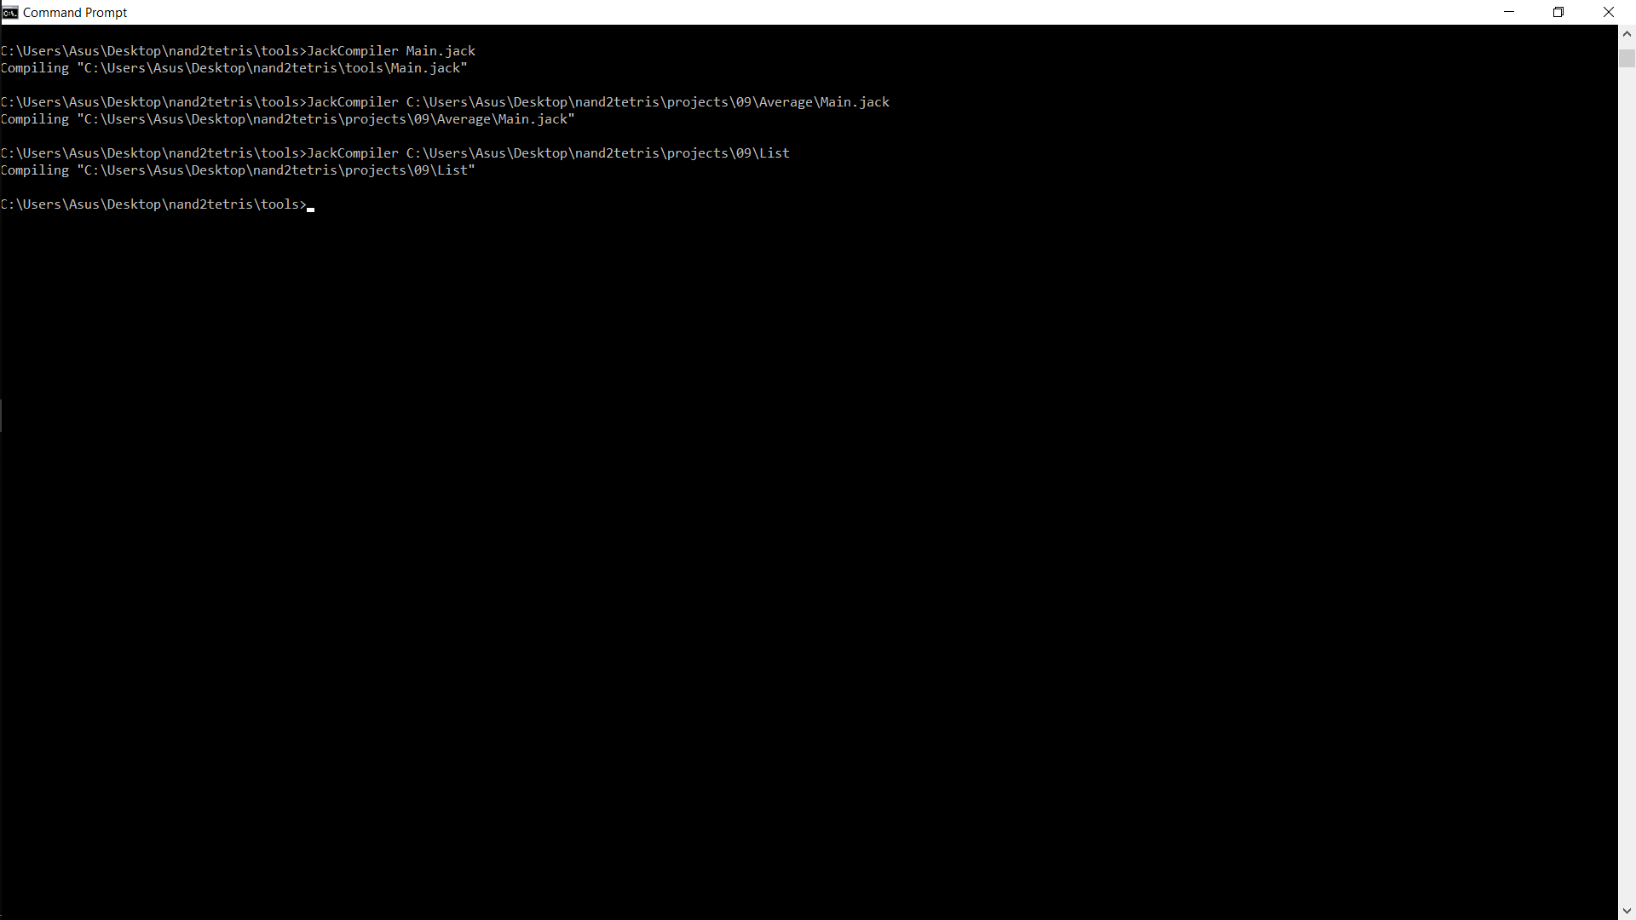

Change the directory where JackCompiler is present

Place the file.jack to the same directory as of JackCompiler and run: JackCompiler file.jack

OR

Run: JackCompiler (location of file.jack)

Both of above two methods can be seen in the picture given above